The Roman Republic
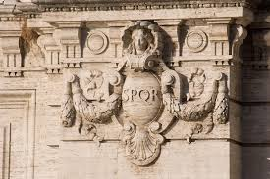
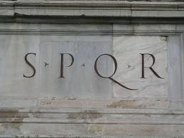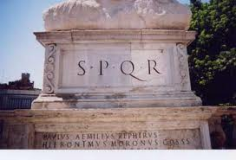

The letters SPQR in this symbol stand for the Latin phrase Senatus Populusque Romanus, which means “the Senate and the people of Rome.” The logo was found on items such as buildings and coins.

Questions.

1. What is the significance of the logo and why would it be important?

2. What symbol is used to represent countries today?

